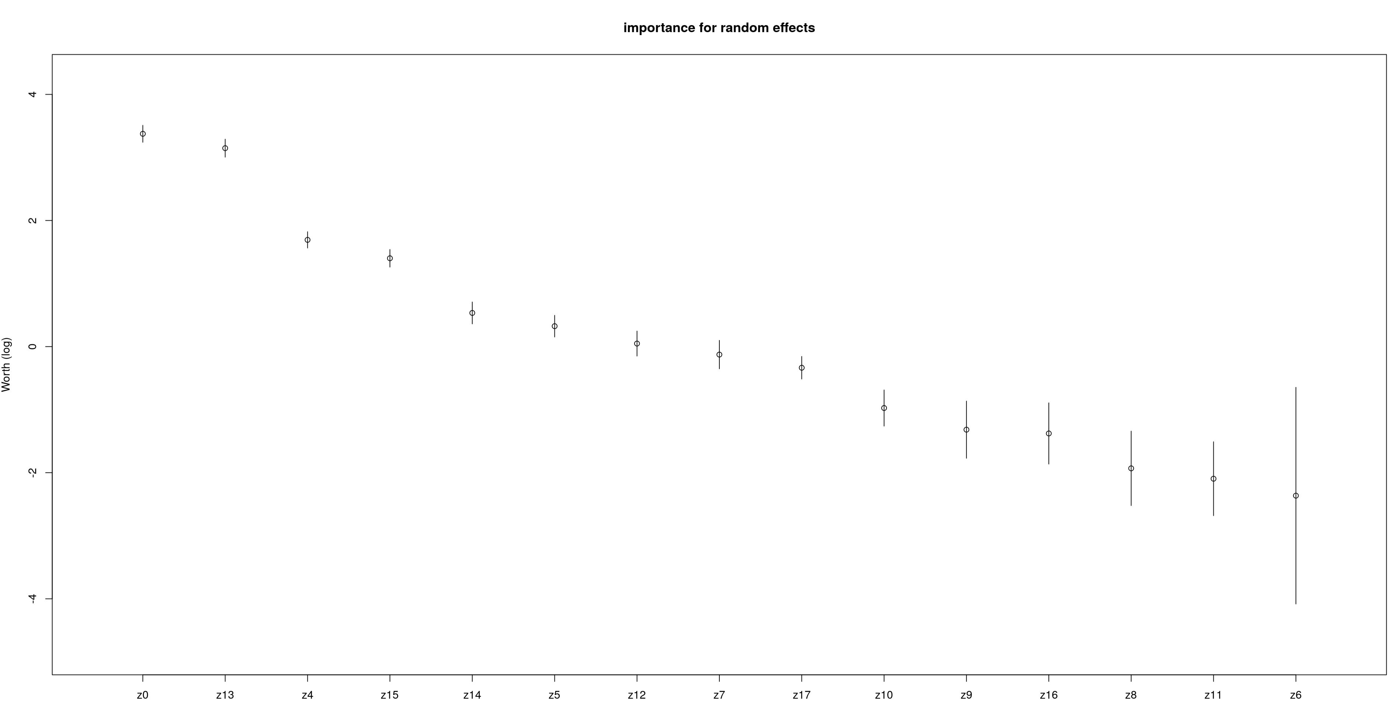

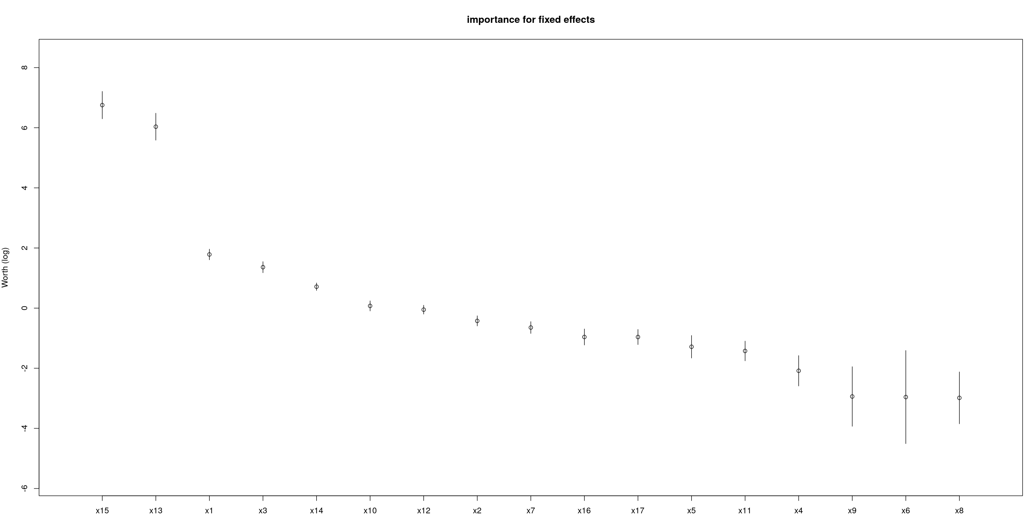

Variable labels | Variable name |  | Variable names
Z0 | Intercept | X9, Z9 | BPI (behavior problems index)
X1 | Mom's age at birth of child | X10, Z10 | SPPCS (self-perception profile: scholastic)
X2 | Child gender | X11, Z11 | SPPCG (self-perception profile: self-worth)
X3 | Mother’s Education | X12, Z12 | DIGIT (Digit span)
X4, Z4 | House size | X13, Z13 | RECOG (reading recognition)
X5, Z5 | Weight of the child | X14, Z14 | COMP (reading comprehension)
X6, Z6 | Height of the child | X15, Z15 | PPVT (vocabulary test score)
X7, Z7 | COGNZ (cognitive stimulation in home) | X16, Z16 | Time spent on homework
X8, Z8 | EMOTZ (emotional support in home) | X17, Z17 | wave

